Week 1: Aap ka pehla AI Agent
Agentic AI Course · Week 1 · Class 1, 2, 3 · step by step

Is hafte aap kya banayen ge
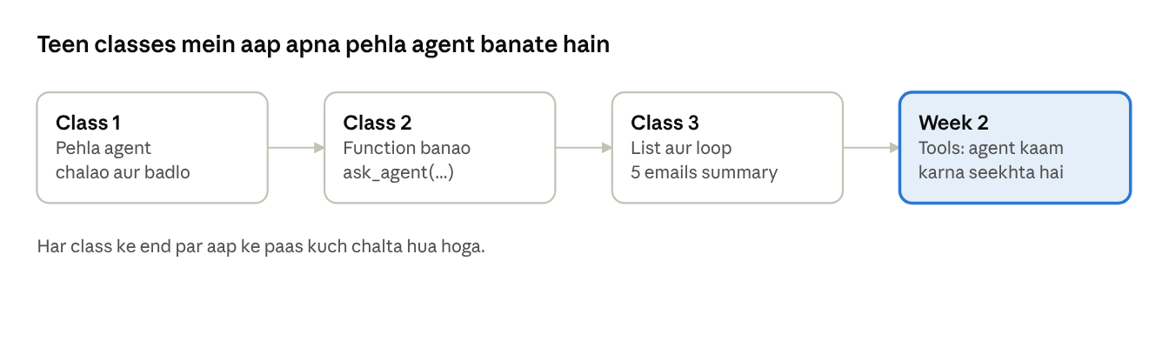
Week 1 roadmap · 3 classes, 1 next step
Har class mein pehle chalao, phir badlo, phir samjho. Code copy-paste karna theek hai, lekin har baar ek cheez badal kar dekho.

Class 0: Setup (sirf ek baar)
Yeh 6 steps class se pehle kar lo.
Step 1: Python
python.org se install karo (3.10 ya naya). Windows par installer mein Add Python to PATH par tick lagao.
Step 2: VS Code
Install karo, phir Python extension lagao.
Step 3: Folder
agentic-course/week1 folder banao. VS Code mein File → Open Folder se kholo.
Step 4: Terminal aur venv
Terminal → New Terminal kholo, phir:
python -m venv .venv
Activate karo:
- Windows: .venv\Scripts\activate
- Mac/Linux: source .venv/bin/activate
Windows "scripts disabled" kahe to ek baar yeh chalao, phir dobara activate karo: Set-ExecutionPolicy -Scope CurrentUser RemoteSigned
Step 5: Packages
pip install openai-agents python-dotenv
Step 6: API key
Key ka tareeqa teacher batayen ge. Key kisi ko mat do, chat mein mat likho.

Teen files banao
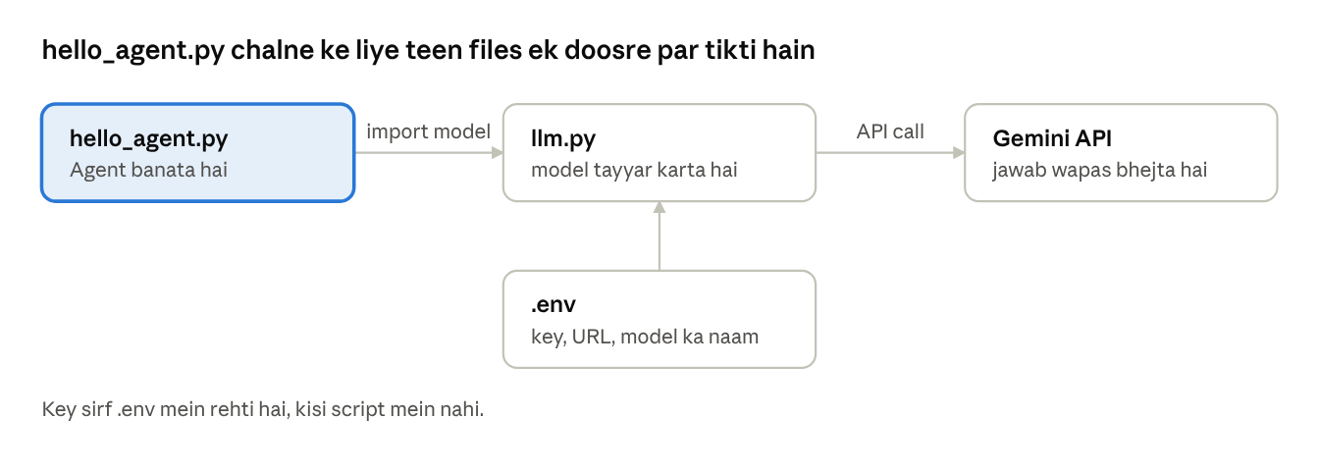
file connections · 4 files, 1 provider
hello_agent.py ko chalne ke liye teeno files chahiye. Teeno ek hi folder mein rakho.
File 1: .env (key yahan rahegi)
API_KEY=yahan_apni_key_paste_karo
BASE_URL=https://generativelanguage.googleapis.com/v1beta/openai/
MODEL_NAME=model_ka_naam_yahan
MODEL_NAME teacher class mein batayen ge.
File 2: llm.py (sirf copy karo, abhi samajhna zaroori nahi)
import os
from dotenv import load_dotenv
from agents import AsyncOpenAI, OpenAIChatCompletionsModel, set_tracing_disabled
load_dotenv()
set_tracing_disabled(disabled=True)
client = AsyncOpenAI(
api_key=os.getenv('API_KEY'),
base_url=os.getenv('BASE_URL'),
)
model = OpenAIChatCompletionsModel(
model=os.getenv('MODEL_NAME'),
openai_client=client,
)
File 3: hello_agent.py
from agents import Agent, Runner
from llm import model
agent = Agent(
name='Assistant',
instructions='Answer concisely.',
model=model,
)
result = Runner.run_sync(agent, 'Write a haiku about Karachi.')
print(result.final_output)

Chalao aur check karo
VS Code mein hello_agent.py kholo aur upar right wala Run (▶) dabao. Ya terminal mein: python hello_agent.py
- ☐ python --version chalta hai
- ☐ Terminal mein (.venv) dikhta hai
- ☐ hello_agent.py ne ek chhoti haiku di

Atak gaye?
Aap ko kya dikha | Kya karo
python command nahi mili | PATH tick ke saath Python dobara install karo
ModuleNotFoundError: agents | venv activate karo, phir pip install dobara
ModuleNotFoundError: llm | llm.py aur script ek hi folder mein rakho
401 ya 403 error | .env mein key dobara paste karo (extra space ya quote nahi)
429 error | 1 minute ruko, dobara chalao

Class 1: Aap ka pehla agent
Aaj ka goal: agent chalao, aur dekho ke instructions badalne se behavior kaise badalta hai.

Step 1: Pehle chalao
hello_agent.py chalao. Jawab aaya? To aap ne apna pehla agent chala diya.

Step 2: Samjho (2 minute)
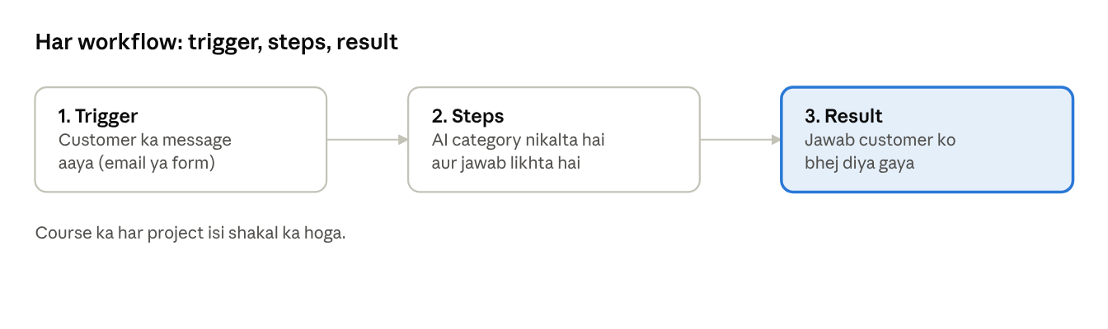
workflow · trigger, steps, result
Kuch hua (trigger), AI ne kaam kiya (steps), natija mila (result).
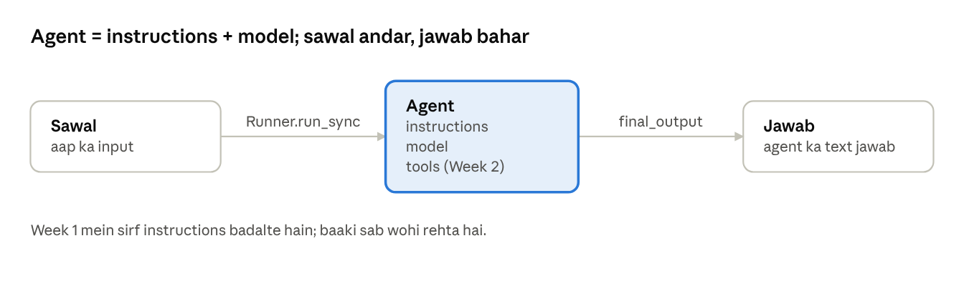
agent anatomy · input, agent, output
- LLM sirf jawab deta hai. Agent kaam karta hai: model + instructions + (baad mein) tools.
- Instructions agent ka job description hain: ek baar likho, har baar wohi behavior.
- Role, format, constraint, example, tone jaise prompting techniques ab instructions mein jaate hain.

Step 3: Experiments
Nayi file s1_experiments.py banao aur yeh paste karo:
from agents import Agent, Runner
from llm import model
# Sirf yeh do cheezen badalni hain
INSTRUCTIONS = 'You are a friendly teacher. Answer in 2 short sentences.'
QUESTION = 'What is an AI agent?'
agent = Agent(
name='Experiment',
instructions=INSTRUCTIONS,
model=model,
)
result = Runner.run_sync(agent, QUESTION)
print(result.final_output)
- Chalao aur jawab padho.
- INSTRUCTIONS ki ek line badlo. QUESTION wohi rakho.
- Dobara chalao aur jawab note karo.
- Neeche ke 5 techniques ek ek karke try karo.
# | Technique | INSTRUCTIONS mein yeh likho
1 | Role | You are a strict exam examiner.
2 | Format | Answer only as 3 bullet points.
3 | Constraint | Use at most 20 words. Never use technical words.
4 | Example | Answer like this: Q: What is Wi-Fi? A: It lets devices use the internet without wires.
5 | Tone | Answer like a Karachi street-food seller, with humour.

Step 4: Likho
Kis technique ne jawab sab se zyada badla? Kis ne sab se kam? 2 line likho.

Challenge: ise todo
INSTRUCTIONS mein likho: Always reply in Spanish. Kya hua? Agar yeh agent kisi client ka hota, to aap is galti se kaise bachte?

Exit ticket
Instructions badalne se agent ka behavior kyun badla? Apne alfaz mein 2 line likho.

Class 2: Function
Aaj ka goal: ek function ask_agent banao jo kisi bhi sawal par agent chalaye.

Step 1: Python ke 6 lafz
Lafz | Matlab | Example
variable | naam wala dabba | name = 'Ali'
string | text, quotes mein | 'hello'
f-string | text mein variable daalna | f'Salam {name}'
function | ek kaam ka naam | def greet(person):
return | function ka jawab wapas dena | return f'Salam {person}!'
input() | user se poochna | input('Naam: ')
Function ke andar ki lines 4 spaces andar ki taraf hoti hain. Isay indentation kehte hain.

Step 2: Chalao
Nayi file s2_basics.py:
name = 'Ali'
age = 20
print('Mera naam', name)
print(f'{name} ki umar {age} saal hai')
def greet(person):
return f'Salam {person}!'
message = greet('Sara')
print(message)
Chalao. Phir name aur age badlo, aur greet ko apna naam do.

Step 3: Function ka nakshah
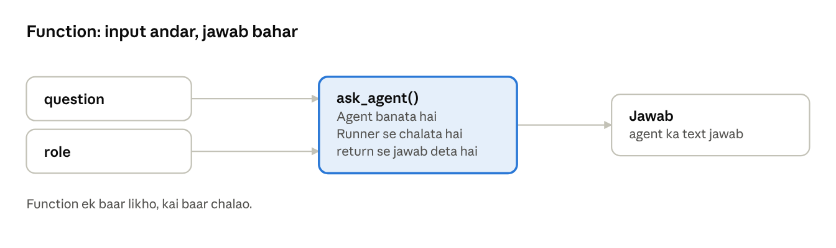
function · 2 inputs, 1 output

Step 4: Agent ko function mein daalo
Nayi file s2_functions.py:
from agents import Agent, Runner
from llm import model
def ask_agent(question, role='helpful assistant'):
agent = Agent(
name='Helper',
instructions=f'You are a {role}. Answer in 3 short lines.',
model=model,
)
result = Runner.run_sync(agent, question)
return result.final_output
name = input('Aap ka naam: ')
question = input('Sawal: ')
print(f'Salam {name}!')
print(ask_agent(question))
print('---')
print(ask_agent(question, role='strict teacher'))
Aap ka task:
- ask_agent ko 3 alag role ke saath chalao.
- Apna naya function banao: ask_in_style(question, style). style instructions mein jaye (jaise 'funny', 'formal').
- Usay 2 alag sawalon par chalao.

Challenge: ise todo
return ki jagah print likho. print(ask_agent(question)) mein None kyun aaya?

Exit ticket
Function kya hai, aur hum agent ko function mein kyun rakhte hain? 2 line likho.

Class 3: List, loop, error
Aaj ka goal: ek saath 5 emails ka summary banao, aur error padhna seekho.

Step 1: Teen naye lafz
Lafz | Matlab | Example
list | items ki qatar | ['a', 'b', 'c']
loop | har item par wohi kaam | for email in emails:
dict | naam aur value ka jora | {'id': 101, 'customer': 'Sara'}

Step 2: Loop chalao
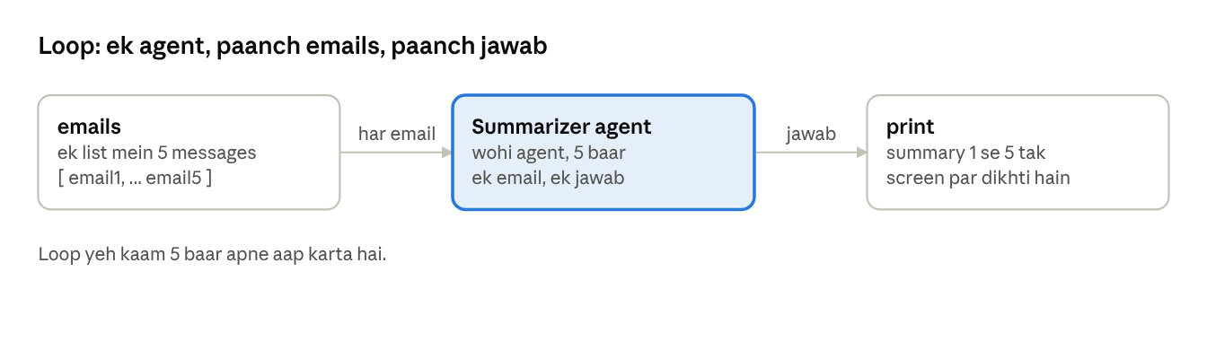
loop · 5 emails, 1 agent
Nayi file s3_loop.py:
from agents import Agent, Runner
from llm import model
summarizer = Agent(
name='Summarizer',
instructions='Summarize the text in one short sentence. Use simple English.',
model=model,
)
emails = [
'Hi, my order #123 has not arrived after 10 days. Please help.',
'Do you have this ring in silver? Also what is the price?',
'I want to return my bracelet, the clasp is broken.',
'Can you ship to Lahore and how long will it take?',
'Thanks, the necklace arrived and it looks beautiful!',
]
for number, email in enumerate(emails, start=1):
result = Runner.run_sync(summarizer, email)
print(f'{number}. {result.final_output}')
- Chalao. 5 summary dikhni chahiye.
- Instructions badlo: Reply with only one word: complaint, question or praise. Dobara chalao.
- Apni khud ki 5 messages (apne capstone idea ke mutabiq) likho aur chalao.

Step 3: Dict (chhota sa)
Nayi file s3_dict.py:
ticket = {
'id': 101,
'customer': 'Sara',
'message': 'My order has not arrived.',
}
print(ticket['customer'])
print(ticket['message'])
ticket['status'] = 'open'
print(ticket)

Step 4: Error padhna
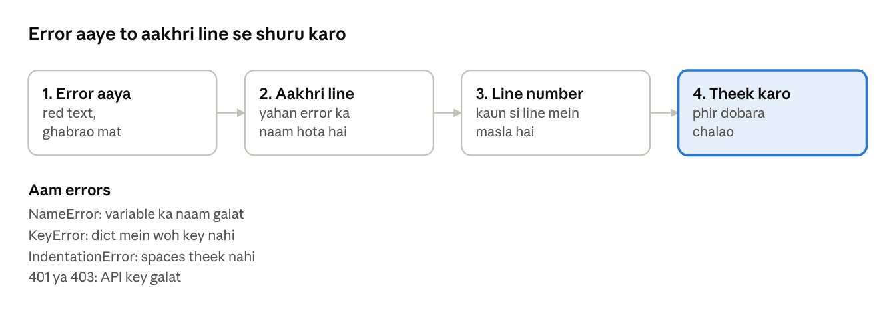
error padhne ka flow · 4 steps
Nayi file s3_errors.py. Ek waqt mein ek bug chalao, baqi bugs ki lines ke aage # laga do:
from agents import Agent, Runner
from llm import model
agent = Agent(name='Test', instructions='Answer briefly.', model=model)
result = Runner.run_sync(agent, 'Hello')
# Bug 1 (NameError)
print(resutl.final_output)
# Bug 2 (KeyError)
ticket = {'id': 101}
print(ticket['name'])
# Bug 3 (IndentationError)
def hello():
print('hi')
Bug 4 (authentication): .env mein key ka ek harf badlo aur chalao. Phir wapis theek karo.
Har bug par apne aap se poochho:
- Kaun si line?
- Error ka naam kya hai?
- Wajah kya hai?
- Theek kaise karen?

Step 5: Apna capstone idea
Teen options mein se ek chuno aur ek line likho: "Mera agent [kis ke liye] [kya kaam] karta hai."
- Clinic appointment assistant
- E-commerce customer support agent
- Lead qualification bot

Homework (20 minute se zyada nahi)
s3_loop.py mein apne capstone idea ke 5 sawal daalo aur category nikalwao. Output ka screenshot ya paste lao.

Exit ticket
Error aaye to sab se pehle aap kya karte hain? 1 line likho.

Week 1 ke end par aap yeh kar sakte hain
- ☐ Agent aur workflow kya hota hai, 1 line mein bata sakte hain
- ☐ Instructions badal kar agent ka behavior badal sakte hain
- ☐ Function, list, loop aur dict basic level par likh sakte hain
- ☐ Error aaye to aakhri line se shuru karte hain
- ☐ Apne capstone ka ek line likh chuke hain

